My Academy team at Cognizant want to create a dashboard containing the details of ongoing and completed cohorts. A react application is created which displays the detail of the cohorts using react component. You are assigned the task of styling these react components.

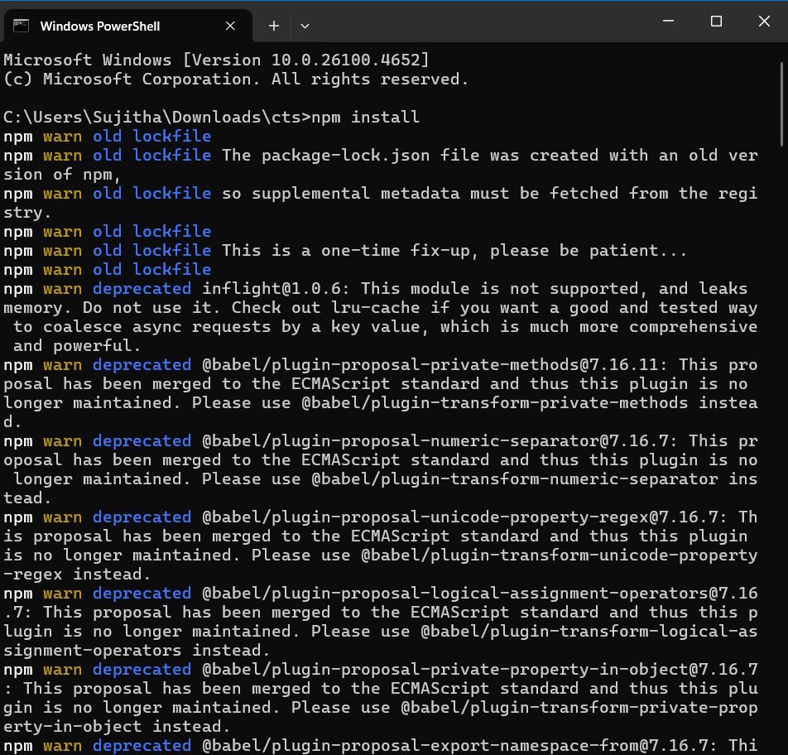

CohortDetails.module.css

/\* CohortDetails.module.css \*/

.box {

  width: 300px;

  display: inline-block;

  margin: 10px;

  padding: 10px 20px;

  border: 1px solid black;

  border-radius: 10px;

}

dt {

  font-weight: 500;

}

CohortDetails.js

// CohortDetails.js

import styles from './CohortDetails.module.css';

function CohortDetails(props) {

    return (

        <div className={styles.box}>

            <h3 style={{ color: props.cohort.currentStatus === 'ongoing' ? 'green' : 'blue' }}>

                {props.cohort.cohortCode} -

                <span>{props.cohort.technology}</span>

            </h3>

            <dl>

                <dt>Started On</dt>

                <dd>{props.cohort.startDate}</dd>

                <dt>Current Status</dt>

                <dd>{props.cohort.currentStatus}</dd>

                <dt>Coach</dt>

                <dd>{props.cohort.coachName}</dd>

                <dt>Trainer</dt>

                <dd>{props.cohort.trainerName}</dd>

            </dl>

        </div>

    );

}

export default CohortDetails;

Output

